Amazon Follow Seller API

创建任务
提交 Amazon 商品跟卖卖家（Follow Seller）抓取任务

请求URL
Copy
Plain Text
POST https://scrapeapi.pangolinfo.com/api/v1/scrape/follow-seller

请求头
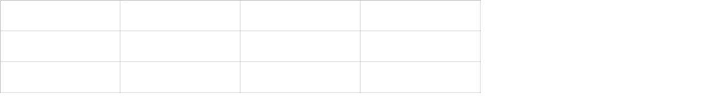
点击图片可查看完整电子表格

请求参数

点击图片可查看完整电子表格

bizContext业务上下文参数说明
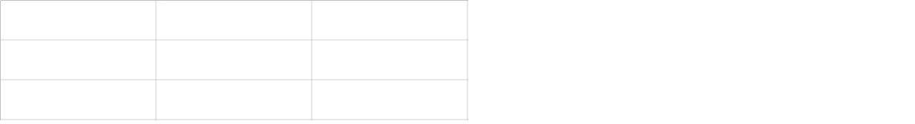
点击图片可查看完整电子表格

响应值
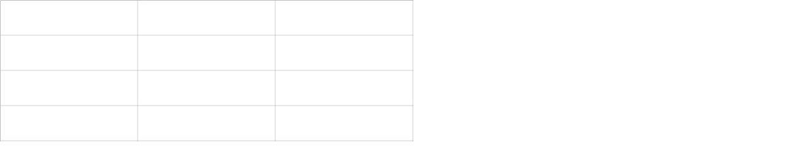
点击图片可查看完整电子表格

返回参数 data 说明

点击图片可查看完整电子表格

请求示例
Copy
Bash
curl --request POST \ --url https://scrapeapi.pangolinfo.com/api/v1/scrape/follow-seller \ --header 'Authorization: ' \ --header 'Content-Type: application/json' \ --data '{ "url": "https://www.amazon.com", "bizContext": { "zipcode": "10041", "asin": "B0G4QPYK4Z" }}'

返回示例
Copy
JSON
{ "code":0, "message":"ok", "data":{ "json":[{"metadata":{"executionTime":141,"parserType":"amzFollowSeller","parsedAt":"2026-01-21T02:01:26.414Z"},"code":0,"data":{"items":[{"delivery":"Wednesday, January 28","price":"$59.23","soldBy":"Amazon Resale","options":"Used \n - Very Good","shipsFrom":"Amazon.com"}]},"message":"ok"}], "url":"https://www.amazon.com", "taskId":"543fefe869cc4c3d9e37a3462f63681c" }}

积点消耗说明
1个/次
Amazon Scrape APIAmazon Async API

